Experiment 4

Polygon Clipping using Sutherland–hodgman Algorithm

**Aim:**

To write a program that clips a polygon to a specified rectangular window using the Sutherland–Hodgman Polygon Clipping Algorithm and displays the clipped polygon.

**Code:**

import matplotlib.pyplot as plt

def intersect(p1, p2, edge, edge_val):

x1, y1 = p1

x2, y2 = p2

dx = x2 - x1

dy = y2 - y1

if edge in ('left', 'right'):

if dx == 0:

return (edge_val, y1)

t = (edge_val - x1) / dx

y = y1 + t * dy

return (edge_val, y)

else:

if dy == 0:

return (x1, edge_val)

t = (edge_val - y1) / dy

x = x1 + t * dx

return (x, edge_val)

def clip_with_edge(polygon, edge, edge_val):

if not polygon:

return []

def inside(p):

x, y = p

if edge == 'left':

return x >= edge_val

if edge == 'right':

return x <= edge_val

if edge == 'bottom':

return y >= edge_val

if edge == 'top':

return y <= edge_val

raise ValueError("Unknown edge")

output = []

prev = polygon[-1]

for curr in polygon:

prev_in = inside(prev)

curr_in = inside(curr)

if prev_in and curr_in:

output.append(curr)

elif prev_in and not curr_in:

output.append(intersect(prev, curr, edge, edge_val))

elif not prev_in and curr_in:

output.append(intersect(prev, curr, edge, edge_val))

output.append(curr)

else:

pass

prev = curr

return output

def sutherland_hodgman(subject_polygon, clip_rect):

"""Clip subject_polygon to clip_rect using Sutherland–Hodgman.

subject_polygon: list of (x,y)

clip_rect: (xmin, ymin, xmax, ymax)

returns clipped polygon (list of (x,y))

"""

xmin, ymin, xmax, ymax = clip_rect

clipped = subject_polygon

clipped = clip_with_edge(clipped, 'left', xmin)

clipped = clip_with_edge(clipped, 'right', xmax)

clipped = clip_with_edge(clipped, 'bottom', ymin)

clipped = clip_with_edge(clipped, 'top', ymax)

return clipped

def plot_polygons(subject_polygon, clipped_polygon, clip_rect, ax=None):

if ax is None:

fig, ax = plt.subplots(figsize=(7,7))

# Original polygon

xs = [p[0] for p in subject_polygon] + [subject_polygon[0][0]]

ys = [p[1] for p in subject_polygon] + [subject_polygon[0][1]]

ax.plot(xs, ys, '-o', label='Original polygon', linewidth=1.5)

#Clipped polygon

if clipped_polygon:

cx = [p[0] for p in clipped_polygon] + [clipped_polygon[0][0]]

cy = [p[1] for p in clipped_polygon] + [clipped_polygon[0][1]]

ax.plot(cx, cy, '-o', label='Clipped polygon', linewidth=2.0)

else:

ax.text(0.02, 0.98, "Result: empty (fully clipped)", transform=ax.transAxes,

va='top', color='red')

# Clipping rectangle

xmin, ymin, xmax, ymax = clip_rect

rect_x = [xmin, xmax, xmax, xmin, xmin]

rect_y = [ymin, ymin, ymax, ymax, ymin]

ax.plot(rect_x, rect_y, '--', label='Clipping window', linewidth=1.2)

ax.set_aspect('equal', 'box')

ax.set_xlabel('X')

ax.set_ylabel('Y')

ax.set_title('Sutherland–Hodgman Polygon Clipping')

ax.legend()

ax.grid(True)

plt.show()

if __name__ == "__main__":

subject = [

(1, 2), (4, 6), (8, 5), (7, 2), (5, 1), (3, 0.5)

]

clip_window = (2.0, 1.0, 6.0, 4.5)

clipped = sutherland_hodgman(subject, clip_window)

print("Original polygon vertices:")

for p in subject:

print(f" {p}")

print("\nClipped polygon vertices:")

if clipped:

for p in clipped:

print(f" ({p[0]:.4f}, {p[1]:.4f})")

else:

print(" <empty>")

# Plot

plot_polygons(subject, clipped, clip_window)

Output:

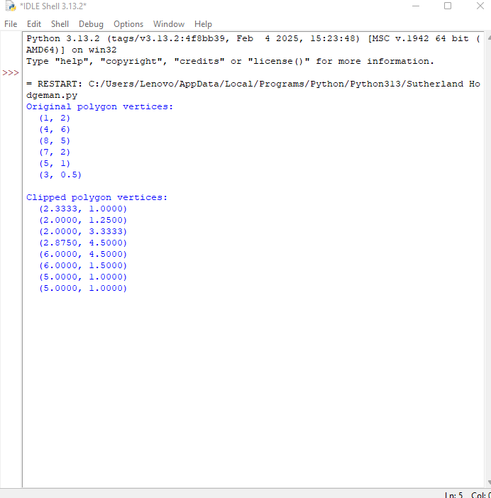

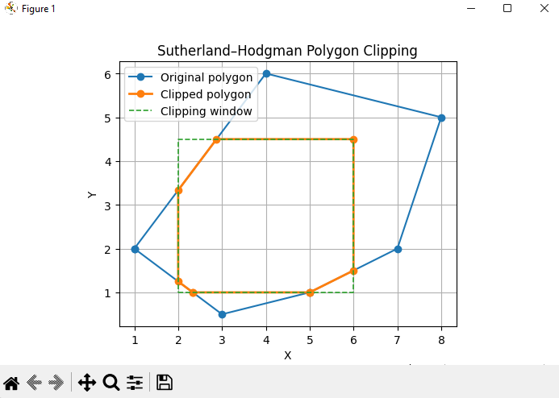

**Conclusion:**

The polygon was successfully clipped using the Sutherland–Hodgman algorithm against a rectangular clipping window.